Azure Portal
- Public web-based interface for management of Azure platform
- Designed for self-service
- Customizable
- Simple tasks
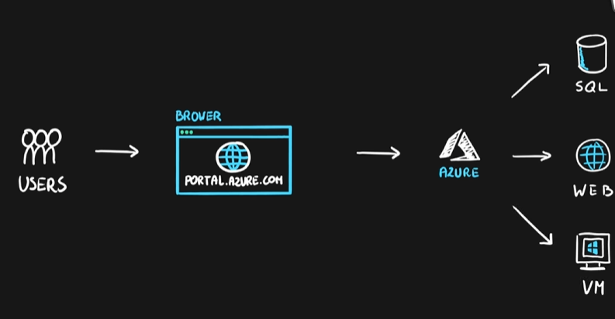

Azure PowerShell
- PowerShell and module
- Designed for automation
- Multi-platform with PowerShell Core
- Simple to use
  - Connect-AzAccount – log into Azure
  - Get-AzResourceGroup – list resource groups
  - New-AzResourceGroup – create new resource group
  - New-AzVm – create virtual machine
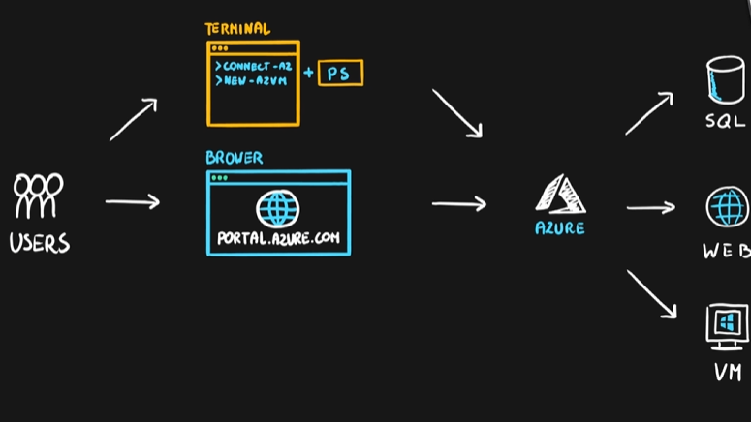

Azure CLI
- Command Line Interface for Azure
- Designed for automation
- Multi-platform (Python)
- Simple to use
  - az login – log into Azure
  - az group list – list resource groups
  - az group create – create new resource group
  - az vm create – create virtual machine
- Native OS terminal scripting
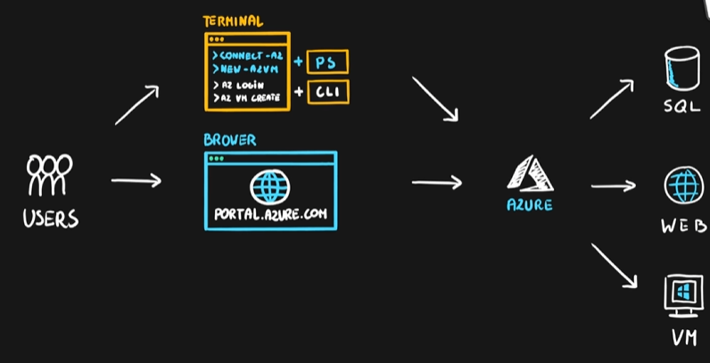

Azure Cloud Shell
- Cloud-based scripting environment
- Completely free
- Supports both Azure PowerShell and Azure CLI
- Dozen of additional tools
- Multiple client interfaces
  - Azure Portal integration (portal.azure.com)
  - Shell Portal (shell.azure.com)
  - Visual Studio Code Extension
  - Windows Terminal
  - Azure Mobile App
  - Microsoft Docs integration
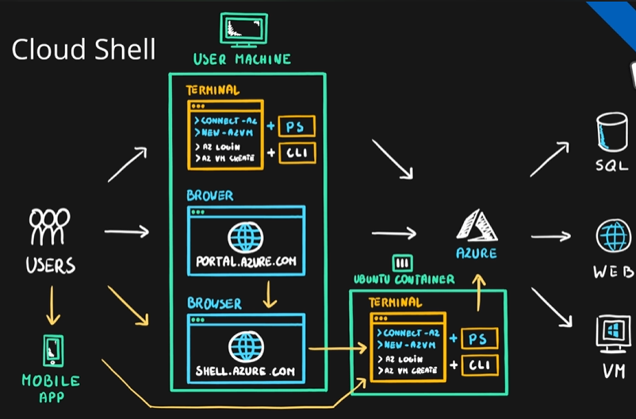

Summary
